Introduction :

A database management system(DBMS) is a collection of interrelated data and a set of programs to access those data. The primary goal of a DBMS is to provide a way to store and retrieve database information that is both convenient and efficient.

Database systems are designed to manage large bodies of information. These days database systems are used in different field like enterprise, university, bank and finance, airlines, telecommunication sector to manage large amount of data.

Database systems arose in response to early methods of computerized management of commercial data. Before that people were using File system to store data. But it is hard to access data from File system, also data stored in File system is not secure. To combat those problem and easy access of data computer scientist developed relational database model.

Database design have several criteria like database schema, schema diagram and E-R diagram (Entity Relationship diagram).

We are designing E-R diagram for Company Data database. To do that we also need to create some table.

Schema :

employee(emp_id, name, birth_date, salary, super_id, branch_id)
branch(branch_id, branch_name, mgr_id)
client(client_id, client_name, branch_id)
branch_supplier(branch_id, supplier_name, supply_type)
works_on(emp_id, client_id, total_sale)

Schema diagram :

Employee

emp_id
name
birth_date
salary
super_id
branch_id
works_on

emp_id
client_id
total_sale
Client

client_id
client_name
branch_id
branch_supplier

branch_id
supplier_name
supply_type

Branch

branch_id
branch_name
mgr_id

Table Based on schema :

employee :

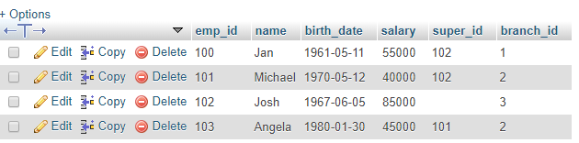
branch :

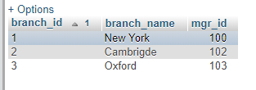

client :

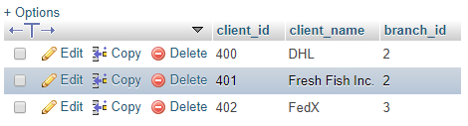

branch_supplier :

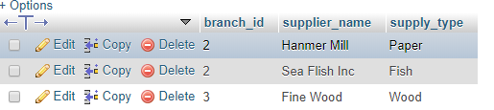

works_on :

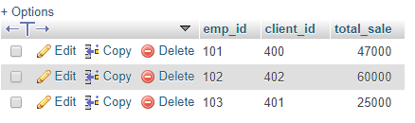

All Table :

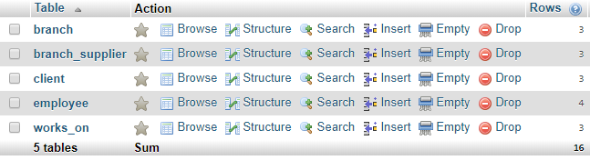

E-R Diagram :

works_for
Branch Supplier
client
Manages
employee
Supplies
Handels
Works with
branch_id
emp_id
supplier_name
client_id
supply_type
branch_name
client_name
sale
birth_date
name
salary
barnch

E-R Diagram Description :

- Here ‘client’, ‘branch’, ‘employee’ are strong entity and has strong relation and each entity has more than one attribute

- ‘branch’ and ‘employee’ has many to many works for relationship, as an employee can work in many branch and many employee can work in one branch.

- In ‘manages’ relation the branch ‘participate’ fully and ‘employee’ participate partially

- In ‘handles’ relation the branch participate partially as one branch can take many client and the ‘client’ participate fully as many client can be served at one branch

- In ‘works with’ relation ‘client’ participate fully and the ‘employee’ participate partially

- In ‘supplies’ relation ‘branch’ participate partially and ‘branch supplier’ participate fully

- ‘Branch Supplier’ is a weak entity, so it does not participate in all relation

Software Used :

1. XAMPP – For database creation and management
2. LibreOffice – For writing the documentation

Reference :
1. Database System Concepts by
Abraham Silberschatz
Henry F. Korth
S. Sudarshan
2. Internet

